# Question50 Implement relational data stores - D

Your company is using various SQL and no-SQL databases in the Microsoft Azure cloud and on-premises to collect and store logistics data. However, business users struggle to build their Business Intelligence (BI) reports because of inconsistency and complexity of existing data stores.  
  
You plan to consolidate the required data and make it available for BI reporting from a centralized Azure SQL Data Warehouse. You plan to use PolyBase as a mechanism for the data load.  
  
As a first step, you automate the data extract from the source databases to Azure Data Lake Storage Gen2. You also create a new Azure SQL Data Warehouse resource and set up a service principal in Azure Active Directory (Azure AD).  
  
You need to define external tables in your Azure SQL Data Warehouse, so that PolyBase can understand where and how to access your extracted data files, before it can load the data.  
  
Which four actions should you perform in sequence? To answer, move the appropriate actions from the list of possible actions to the answer area and arrange them in the correct order.

Create a list in the correct order

Possible actions

Actions in order

* Create a clustered columnstore index.
* Execute DBCC OPENTRAN.
* Create a database master key.
* Create a database scoped credential.
* Create an external data source and external file format.
* Create an external table.

# Question51 Implement relational data stores – D -

You are a data engineer for a utility billing solutions company. Your company has five customers that use your company for utility billing. Each customer has different peak usage periods within the year. In the legacy environment, each customer has its own database. You deploy an Azure SQL Database elastic pool.  
  
You need to configure the number of data transaction units (DTUs) to minimize cost.

What should you do?

Choose the correct answer

Determine the number of total DTUs that are used by all five databases combined.

Determine the number of DTUs that are used by the largest database.

Determine the number of DTUs that are used by the database with the most transactions.

Determine the number of DTUs that are used by the database with the longest peak period.

# Question52 Implement relational data stores - D

You are a data engineer for your company. Your company is planning to upgrade a customer's web application to use a different user interface technology. You create an Azure SQL Database instance that the developers will use while developing the application. Developers must only be able to access the database while on the company's premises.  
  
You need to configure the database to meet these requirements.  
  
What should you do?

Choose the correct answer

Run the New-AzSqlServerFirewallRule PowerShell cmdlet.

Add role assignments on the Access control (IAM) page of the Azure portal.

Run the az sql db audit-policy Azure CLI command.

Set the Allow access to Azure services setting to off in the Azure portal.

# Question53 Implement relational data stores - D

You are a data engineer for your company. Your company has an on-premises SQL Server instance that contains 16 databases. Four of the databases require Common Language Runtime (CLR) features.  
  
You must be able to manage each database separately because each database has its own resource needs. You plan to migrate these databases to Azure. You want to migrate the databases by using a backup and restore process by using SQL commands.  
  
You need to choose the most appropriate deployment option to migrate the databases.  
  
What should you use?

Choose the correct answer

Azure Cosmos DB with the Table API

Azure Cosmos DB with the SQL (DocumentDB) API

Azure SQL Database managed instance

Azure SQL Database with an elastic pool

# Question54 Implement relational data stores – D -

You are a data engineer for your company. You deploy an Azure SQL Database instance with the single database deployment option. You want to give an existing user named Sam administrative rights to the database. Sam must be able to add and remove other users.  
  
You need to complete the T-SQL command.  
  
How should you complete the command? To answer, select the appropriate options from the drop-down menus.

Choose the correct options

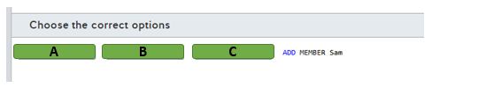

A)

1. Alter
2. Create
3. Grant

B)

1. LOGIN
2. ROLE
3. USER

C)

1. db_datareader
2. db_datawrite
3. db_owner

# Question55 Implement relational data stores-

You are a data engineer for your company. You create an Azure SQL Database server named autoone. You want to deploy two databases to this server. You want to allow both databases to share the resources provided by the server.  
  
How should you complete the commands? To answer, select the appropriate options from the drop-down menus.

az <<< A >>> create -n shared -s autoone  
az <<< B >>> create -n database1 -s autoone -- <<< C >>> shared  
az <<< D >>> create -n database2 -s autoone -- <<< E >>> shared

**<<< A >>> Options**

1. CosmosDB

2. SQL Elastic-Pool

3. SQL DB

**<<< B >>> Options**

1. CosmosDB database

2. sql db

3. sql elastic-pool

**<<< C >>> Options**

1. elastic-pool

2. zone-redundant

**<<< D >>> Options**

1. CosmosDB

2. SQL Elastic-Pool

3. SQL DB

**<<< E >>> Options**

1. elastic-pool

2. zone-redundant

Choose the correct options

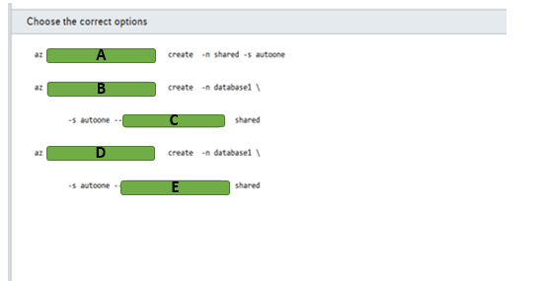

A)

1. Cosmodb
2. Sql elastic-pool
3. Sql db

B)

1. Cosmodb database
2. Sql db
3. Sql elastic pool

C)

1. Elastic pool
2. Zone-redundant

D)

1. Cosmodb database
2. Sql db
3. Elastic pool

E)

1. Elastic-pool
2. Zone-redundant

# Question56 Implement relational data stores -

You are a data engineer for your company. You create an Azure SQL Data Warehouse instance to house inventory data for 30 stores. There are approximately 10,000 products among the stores, with each distinct type of product having a different stock keeping unit (SKU). The inventory data will be captured every Friday. Friday updates cause massive changes to inventory data. You want to shard the data to improve performance.  
  
You need to write a T-SQL statement to generate the table.  
  
How should you complete the statement? To answer, select the appropriate code segments from the drop-down menus.

Choose the correct options

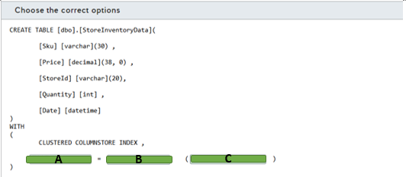

A)

1. Distribution
2. Partition

B)

1. HASH
2. REPLICATE
3. ROUND_ROBIN

C)

1. Sku
2. StoreID

# Question57 Implement relational data stores-

You are a data engineer for your company. You create an Azure SQL Data Warehouse instance to house inventory data for 30 stores. You want to shard the store data to improve performance when accessing store data. The size of the data is less than 200 megabytes (MB).  
  
You need to write a T-SQL statement to generate the store table.  
  
How should you complete the statement? To answer, select the appropriate code segments from the drop-down menus.

Choose the correct options

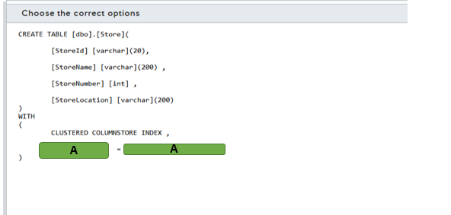

A)

1. DISTRIBUTION
2. PARTITION

B)

1. HASH(StoreID)
2. REPLICATE
3. ROUND_ROBIN

# Question58 Implement relational data stores-

You are a data engineer for your company. You create an Azure SQL Data Warehouse instance to house inventory data for 1000 stores. Each store has a distinct store number. You want to shard the store data to improve performance when accessing store data. You want to ensure that the data is evenly sharded across compute nodes.  
  
You need to write a T-SQL statement to generate the store table.  
  
How should you complete the statement? To answer, select the appropriate code segments from the drop-down menus.

Choose the correct options

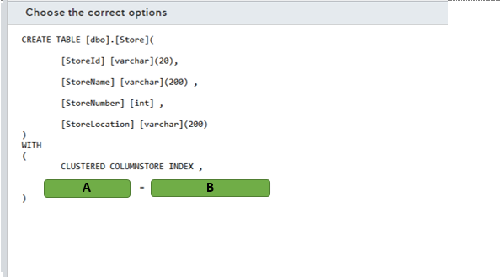

A)

1. DISTRIBUTION
2. PARTITION

B)

1. HASH (Store Number)
2. REPLICATE
3. ROUND_ROBIN

# Question59 Implement relational data stores -

You are a data engineer for your company. You create an Azure Data Warehouse database that uses round robin distribution. You write the following query to retrieve store sales data:  
  
SELECT S.[Amount] AS [Sales], ST.[Name] FROM [FactSalesByStore] AS S JOIN [DimStore] AS ST ON S.[StoreId] = ST.[StoreId]  
  
This query returns over 200,000 records, and it runs slowly. There are over 50,000 stores.  
  
You need to improve the performance of this query.  
  
What should you do?  
  
For each of the following statements, select Yes if you should perform the task. Otherwise, select No.

|  |  |  |
| --- | --- | --- |
| **Statement** | **Yes** | **No** |
| Use hash distribution on StoreId for FactSalesByStore. |  |  |
| Use hash distribution on StoreId for DimStore. |  |  |
| Use replicated distribution for DimStore. |  |  |
| Use an outer join instead of an inner join. |  |  |

# Question60 Implement relational data stores -

You are a data engineer for your company. An Azure blob storage container contains a large comma-separated-value (CSV) file. You want to load the data from that file into an Azure SQL Data Warehouse database table. You run the following SQL statements:  
  
CREATE MASTER KEY;  
  
CREATE EXTERNAL FILE FORMAT TextFile  
WITH (  
FORMAT_TYPE = DelimitedText,  
FORMAT_OPTIONS (FIELD_TERMINATOR = ',')  
);  
  
You need to run four additional SQL statements to load the data from the blob container.   
  
Which four SQL statements should you run? To answer, move the appropriate statements from the list of possible statements to the answer area and arrange them in the correct order.

Create a list in the correct order

Possible SQL statements

SQL statements in order

* CREATE DATABASE
* CREATE DATABASE SCOPED CREDENTIAL
* CREATE EXTERNAL DATA SOURCE
* CREATE EXTERNAL TABLE
* CREATE TABLE

# Question61 Implement relational data stores -

You manage your company’s Manufacturing Execution Solution (MES), which stores data in an Azure SQL Database.  
  
Because of a recent acquisition, you are asked to move the Azure SQL Database to another Azure region, so that the data resides closer to the manufacturing sites.  
  
You need to move the Azure SQL Database to the new region and delete the original Azure SQL Database without losing data.  
  
Which five actions should you perform in sequence? To answer, move the appropriate actions from the list of possible actions to the answer area and arrange them in the correct order.

Create a list in the correct order

Possible actions

Actions in order

* Monitor the sync process with the Get-AzSqlDatabaseFailoverGroup cmdlet and verify that its ReplicationState is equal to 0.
* Execute the Switch-AzSqlDatabaseFailoverGroup cmdlet by using the failover group’s read-write listener endpoint.
* Create a failover group and add the original Azure SQL Database.
* Monitor the sync process with the Get-AzSqlDatabaseFailoverGroup cmdlet and verify that its ReplicationState is equal to 2.
* Execute the Switch-AzSqlDatabaseFailoverGroup cmdlet by using the failover group’s read-only listener endpoint.
* With the NSLOOKUP command, verify the swap of IP addresses between the failover group’s read-write and read-only listeners.
* Delete the failover group and the original Azure SQL Database.

# Question62 Implement relational data stores -

You are deploying a new e-commerce solution in the Microsoft Azure environment that uses Azure SQL Database as its relational data store.  
  
As a part of the business continuity plan, you enable active geo-replication of the primary database to the secondary database in another Azure region.  
  
The Marketing team wants you to update the price list in Azure SQL Database shortly after the announcement of the new product ranges.  
  
You need to ensure that the price changes made in the primary database are replicated synchronously to the secondary database.

What should you do?

Choose the correct answer

Run the Get-AzSqlDatabaseReplicationLink Az PowerShell cmdlet after the change, using the connection string of the primary database.

Call the sp_wait_for_database_copy_sync procedure in the primary database after the change.

Call the sp_wait_for_database_copy_sync procedure in the secondary database after the change.

Verify in the sys.geo_replication_links view of Azure SQL database that the replication_state field of the secondary database record is set to 1.

# Question63 Implement relational data stores -

You manage an Azure SQL database hosted in the Central US Azure region.  
  
You need to synchronize the database with another Azure SQL Database instance that will be created in the East US Azure region. These databases will be used by a distributed application with write and read permission.  
  
You need to perform an initial data sync with the new database with minimal downtime and enable bi-directional sync after the initial sync.

Choose the correct answer

Azure SQL Data Sync

Azure SQL active geo-replication

Azure Database Migration Service

Data Migration Assistant (DMA)

# Question64 Implement relational data stores -

Your company manages a modern data warehouse solution. Part of this solution consists in an Azure SQL Data Warehouse and Azure Data Lake Storage Gen2.   
  
You need to configure PolyBase to load data from Azure Data Lake Storage Gen2 in a fact table named FactCarSales. This solution should not use service principals in Azure Active Directory (Azure AD).   
  
Which five actions should you perform in sequence? To answer, move the appropriate actions from the list of possible actions to the answer area and arrange them in the correct order.

Create a list in the correct order

Possible actions

Actions in order

* Create an external data source with the BLOB_STORAGE type.
* Create a scoped credential with the Client Id and OAuth 2.0 token endpoint.
* Create a scoped credential with the Azure storage account key.
* Create an external data source with the HADOOP type.
* Create an external file format.
* Create an external table.
* Load the data into the FactCarSales table.

# Question65 Implement relational data stores -

Your company is planning to migrate an on-premises data warehouse to Azure SQL Data Warehouse.   
  
Some SQL Data Warehouse tables need special attention before the migration:

* There is a large fact table named FactSales with 5 terabytes (TB). Queries involving this table use a primary key defined in the SaleKey column to retrieve data.
* A dimension table named DimBusinessUnits with 200 megabytes (MB) is used by almost all reports.
* A staging table named StagingFactSales is used during the extract, transform, and load (ETL) process to load new data to the FactSales table.

You need to migrate these tables and configure the appropriate distribution strategy for each table to optimize query performance.   
  
Which distribution strategy should you use? To answer, drag the appropriate distribution to the correct table. Each distribution may be used once, more than once, or not at all.

Drag and drop the answers

https://pts.measureup.com/web/instances/MUP/assets/images/DP-200/DP-200_65256/gsDP-200_013c.gif

https://pts.measureup.com/web/instances/MUP/assets/images/DP-200/DP-200_65256/gsDP-200_013b.gif

https://pts.measureup.com/web/instances/MUP/assets/images/DP-200/DP-200_65256/gsDP-200_013a.gif

https://pts.measureup.com/web/instances/MUP/assets/images/DP-200/DP-200_65256/gsDP-200_013c.gif

https://pts.measureup.com/web/instances/MUP/assets/images/DP-200/DP-200_65256/gsDP-200_013b.gif

https://pts.measureup.com/web/instances/MUP/assets/images/DP-200/DP-200_65256/gsDP-200_013a.gif

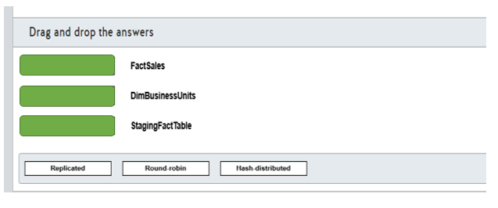

# Question66 Implement relational data stores-

Your team is implementing a new Azure SQL Data Warehouse solution in Azure.  
  
You need to use PolyBase to load data from a parquet file stored in an Azure Blob Storage in a table named FactSaleOrders.  
  
You need to configure the Azure SQL Data Warehouse to receive the data.  
  
Which five actions should you perform? To answer, move the appropriate actions from the list of possible actions to the answer area and arrange them in any order.

Create a list in any order

Possible actions

Actions to perform

* Load the parquet file into a staging table.
* Enable Transparent Data Encryption (TDE).
* Enable PolyBase support with the sp_configure command.
* Create a database master key.
* Create an external data source for Azure Blob Storage.
* Create an external table.
* Create an external file format for parquet file.
* Load the data in the FactSaleOrders table using T-SQL.

# Question67 Implement relational data stores-

Your company is provisioning multiple Azure SQL managed instances for an automotive industry application. The application must be resilient in case of an outage impacting an Azure region.  
  
You create a primary instance in the West US region named AutoInsdustry and a secondary instance in the East US region named AutoIndustrySecondary. The instances are provisioned in a resource group named AutoProduction.  
  
You need to implement an auto-failover group for database disaster recovery.  
  
How should you complete the PowerShell cmdlet? To answer, select the appropriate options from the drop-down menus.

Choose the correct options

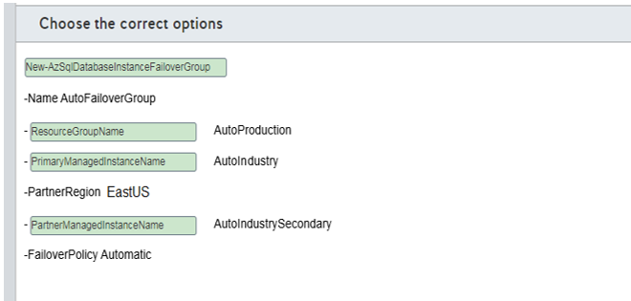

A)

1. New-AzSqlDatabaseFailoverGroup
2. New-AzSqlDatabaseInstanceFailoverGroup
3. Set-AzSqlDatabaseFailoverGroup

B)

1. PartnerManagedInstanceName
2. PrimaryManagedInstanceName
3. ResourceGroupName

C)

1. PartnerManagedInstanceName
2. PrimaryManagedInstanceName
3. ResourceGroupName

D)

1. PartnerManagedInstanceName
2. PrimaryManagedInstanceName
3. ResourceGroupName

# Question68 Implement relational data stores-

You are creating tables for Azure Synapse Analytics.  
  
You need to choose the appropriate types of tables for various needs.  
  
Which table option should you use in the following cases? To answer, drag the appropriate table option to each table category. A table option may be used once, more than once, or not at all.

Drag and drop the answers

https://pts.measureup.com/web/instances/MUP/assets/images/DP-200/DP-200_70382/fake_5e47fc34063a2.png

https://pts.measureup.com/web/instances/MUP/assets/images/DP-200/DP-200_70382/fake_5e47fcb11dcc8.png

https://pts.measureup.com/web/instances/MUP/assets/images/DP-200/DP-200_70382/fake_5e47fcb9c7df8.png

https://pts.measureup.com/web/instances/MUP/assets/images/DP-200/DP-200_70382/fake_5e47fcc250337.png

https://pts.measureup.com/web/instances/MUP/assets/images/DP-200/DP-200_70382/fake_5e47fc34063a2.png

https://pts.measureup.com/web/instances/MUP/assets/images/DP-200/DP-200_70382/fake_5e47fcb11dcc8.png

https://pts.measureup.com/web/instances/MUP/assets/images/DP-200/DP-200_70382/fake_5e47fcb9c7df8.png

https://pts.measureup.com/web/instances/MUP/assets/images/DP-200/DP-200_70382/fake_5e47fcc250337.png

https://pts.measureup.com/web/instances/MUP/assets/images/DP-200/DP-200_70382/fake_5e47fcd10030f.png

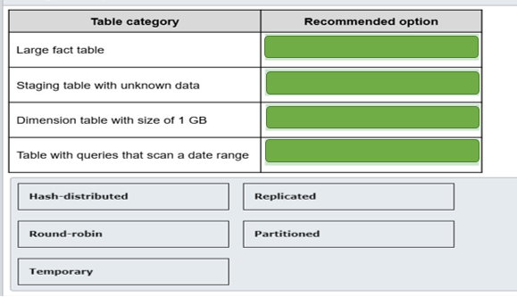

# Question69 Implement relational data stores-

You have an Azure Synapse Analytics database.  
  
You need a list of all hash distributed tables. The list must include the table name and the column name of the distribution column.  
  
Which three catalog views do you need to join in a query? Each correct answer presents part of the solution.

Choose the correct answers

sys.columns

sys.pdw_table_distribution_properties

sys.pdw_distributions

sys.pdw_column_distribution_properties

sys.pdw_nodes_columns

sys.tables

# Question70 Implement relational data stores-

You have a table named Sales in Azure Synapse Analytics SQL pool with the following definition

CREATE TABLE Sales (

ID [int] identity NOT NULL,

CustomerKey [int] NOT NULL,

Amount [money] NOT NULL,

Date [date] NOT NULL)

WITH

(DISTRIBUTION = HASH (CustomerKey),

PARTITION ( [Date] RANGE RIGHT

FOR VALUES ('2018-01-01', '2019-01-01', '2020-01-01', '2021-01-01' )));

The table does not contain dates after the year 2020.  
  
You need to archive the oldest partition (with dates before January 1, 2018). The archive table does not exist, and the name should be SalesHistory.  
After archiving the old data, you need to add a partition to the Sales table for the next year.  
  
Which four actions should you perform in sequence? To answer, move the appropriate actions from the list of actions to the answer area and arrange them in the correct order.

Create a list in the correct order

Possible actions

Actions in order

* Create the SalesHistory table with the same column definitions, data distribution and partition boundaries as the Sales table.  
  Create a check constraint on the Date column limiting the dates to smaller than '2018-01-01'.
* Switch partition 1 of the Sales table to partition 0 of the SalesHistory table.
* Create a new partition in the SalesHistory table with this command:  
  ALTER TABLE SalesHistory SPLIT RANGE ('2022-01-01');
* Create the SalesHistory table with the same column definitions and data distribution as the Sales table. Include one partition boundary as '2018-01-01'.
* Switch partition 1 of the Sales table to partition 1 of the SalesHistory table.
* Remove the boundary value '2018-01-01' in the Sales table by using:  
  ALTER TABLE Sales MERGE RANGE ('2018-01-01');
* Create a new partition in the Sales table with this command:  
  ALTER TABLE Sales SPLIT RANGE ('2022-01-01');